SCRUM Framework and related terms:

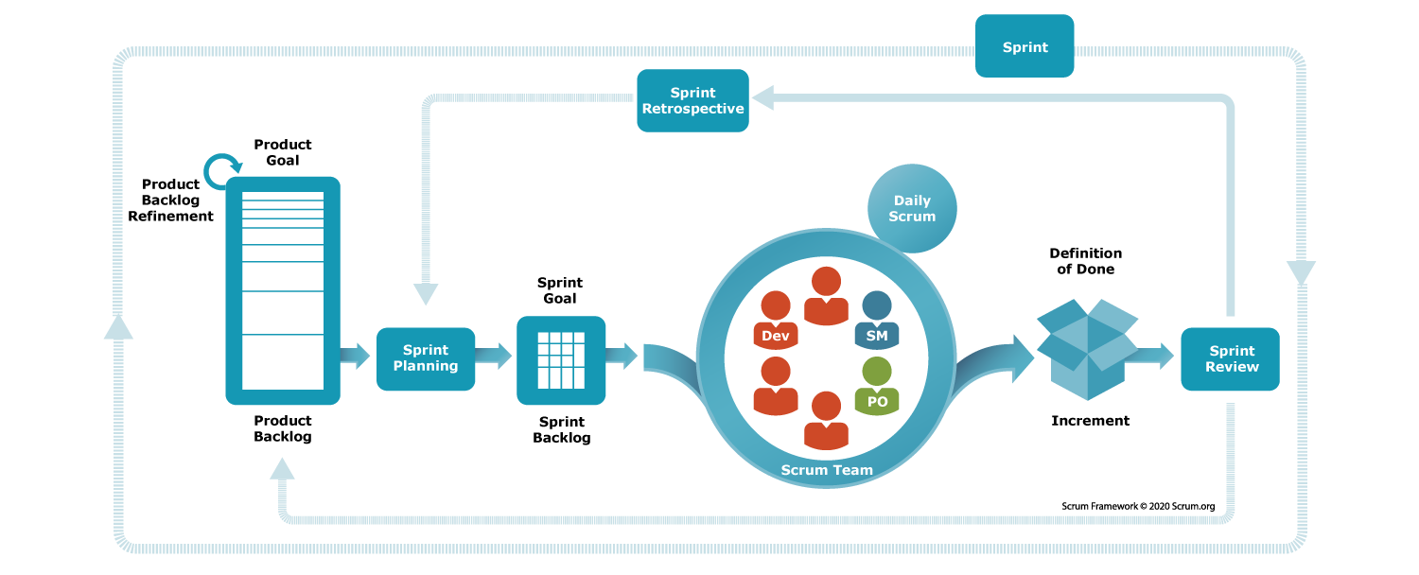

Scrum:

A Scrum framework is an [Agile methodology](https://www.simplilearn.com/benefits-of-agile-methodology-article) that facilitates communication and self-organization within a team.

Scrum is an agile team collaboration framework commonly used in software development and other industries. Scrum prescribes for teams to break work into goals to be completed within time-boxed iterations, called sprints.

Scrum Master:

The Scrum Master is responsible for ensuring that the Scrum framework is understood and followed by the team. They facilitate Scrum events, remove impediments, and coach the team.

Example: Emily is the Scrum Master for the development team. She facilitates the Daily Scrum, helps the team identify and resolve impediments, and ensures that the Sprint progresses smoothly.

Daily Scrum:

Also known as the Daily Stand-up, this is a short daily meeting where team members synchronize their activities, discuss progress, and plan for the day.

Example: During Sprint 1, the team holds a Daily Scrum every morning to discuss what they did yesterday, what they plan to do today, and any obstacles they are facing in implementing the user authentication feature.

Scrum meetings- daily stand up meeting, will discuss the problems, updates, etc related to projects.

3 main things to be discussed in scrum meeting:

1. What u have done yesterday
2. What u have done today
3. What needs to be done tmrw

Sprint:.

1. A sprint is a short, time-boxed period when a scrum team works to complete a set amount of work. Sprints are at the very heart of scrum and agile methodologies, and getting sprints right will help your agile team ship better software with fewer headaches.
2. “With scrum, a product is built in a series of iterations called sprints that break down big, complex projects into bite-sized pieces,"
3. A complex project split into iterations called sprints.
4. time-boxed periods of one week to one month, during which a product owner, scrum master, and scrum team work to complete a specific product addition. During a sprint, work is done to create new features based on the user stories and backlog.
5. 14 days to complete the sprint

Example: The team begins Sprint 1 with a goal to implement the user authentication feature from the Product Backlog within a two-week timeframe.

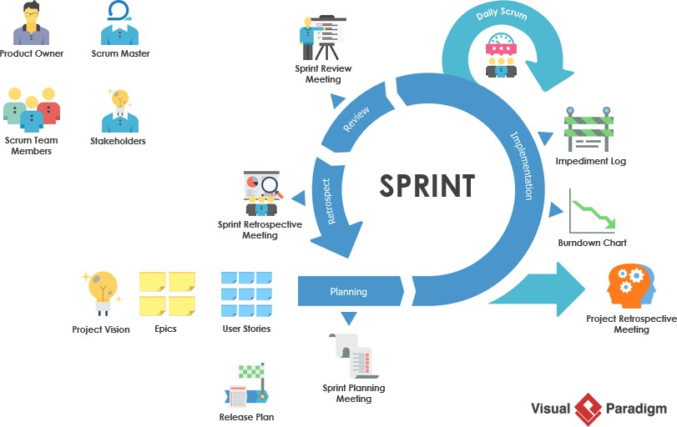

3 types of backlog: product backlog, sprint backlog and release backlog (notes are at the bottom of the page)

Sprint Backlog:

* This is a subset of the Product Backlog items selected for the Sprint, along with a plan for delivering the product Increment and realizing the Sprint Goal. (Need to be completed within a sprint)
* A sprint backlog is a list of work items your team plans to complete during a project sprint.These items are usually pulled from the product backlog during the sprint planning session

Example: The Sprint Backlog for Sprint 1 includes specific tasks related to implementing the user authentication feature, such as designing the login screen, implementing backend APIs, and writing unit test

Sprint Retrospective:

This is a meeting held at the end of each Sprint where the team reflects on their process, identifies what went well and what could be improved, and creates a plan for implementing those improvements in the next Sprint.

Example: After completing Sprint 1, the team holds a Sprint Retrospective to discuss what went well (e.g., effective collaboration) and what could be improved (e.g., clearer acceptance criteria). They decide to refine their estimation process for Sprint 2 to improve accuracy.

Increment:

At the end of each Sprint, the team delivers a potentially shippable product Increment, which is a concrete step toward the product's vision.

In scrum, a product increment is whatever you previously built, plus anything new you just finished in the latest sprint, all integrated, tested, and ready to be delivered or deployed.

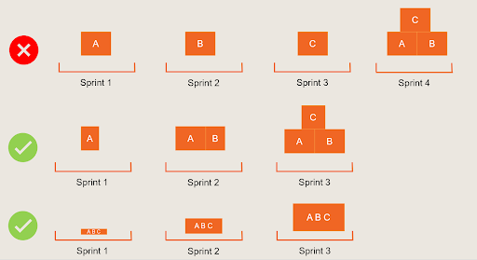

Example: By the end of Sprint 1, the team has successfully implemented the user authentication feature, and it is ready for testing and validation by stakeholders.

Product Owner:

The Product Owner is responsible for managing the Product Backlog, prioritizing the items, and ensuring that the team understands the requirements. (product manager and product owner are different)

Example: John is the Product Owner for a mobile application development project. He collaborates with stakeholders to gather requirements, prioritize features, and maintain a well-groomed Product Backlog.

Product Backlog:

This is an ordered list of all the features, enhancements, and fixes that are needed for the product. The Product Backlog is managed and prioritized by the Product Owner.(overall list of features that we want to implement)

Example: The Product Backlog for the mobile application includes features such as user authentication, in-app purchases, and push notifications, prioritized based on customer feedback and business value.

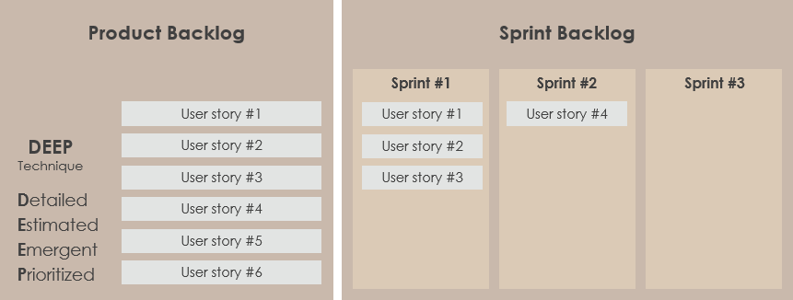

-------------------------------------------------------------------------------------------------------------------------------------

Scrum meeting : Note of these activities : Online yello stickies OR Notepad

- What was achieved yesterday

- What will you do today?

- Any blockers

Are the blockers/dependencies solutions discussed in the Scrum meeting ? NO

Scrum meeting == Daily Standup meeting ?

Project Team : Dev + UI + QA + Customer + PM

c. What are these activities ? :: Tasks/Activities

Need vs Requirement

User needs are collected to make sure your product is usable in the way it was intended.

Design input requirements exist to make sure the design output matches what you wanted to develop

S1 :

Need - I should have a phone

Req - I should have a iPhone

S2 :

Need - I should have food

Req - I should have a food in a 5-star hotel

S3 :

Need - Login feature with username and passwd + submit btn

Req - OTP based validation

What are the types of Backlog :

- Product backlog - Overall list of features that you want to implement BUT is not prioritized

- Sprint backlog - User stories that need to be completed in a specific time period

- Release backlog - Features that are to be implememented in a release

-----------------------------------------------------------------------------------------------------------------------------------------

Retrospective/Retrospective Meeting

D/B Sprint and release

Sprint is a feature or set of features within an product release while a Release is the complete feature set for that particular version of the product.

What is release cycle?   
What is sprint cycle ?

Is release cycle == sprint cycle?

**NO, A sprint ends with a new product increment**, but that may not mean a product release happens

When should the retrospective happen?

<https://www.youtube.com/watch?v=75I_PWPG0-s>

Sprint Plan :

<https://www.youtube.com/watch?v=75I_PWPG0-s>

Burn-down chart?